Lab Practical #12:
Study the concept of routing using packet tracer. (Static Routing)
Practical Assignment #12:
- Connect the two different networks based on the calculated IP addresses and subnet using a packet tracer.
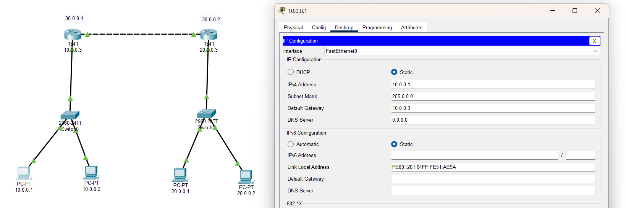
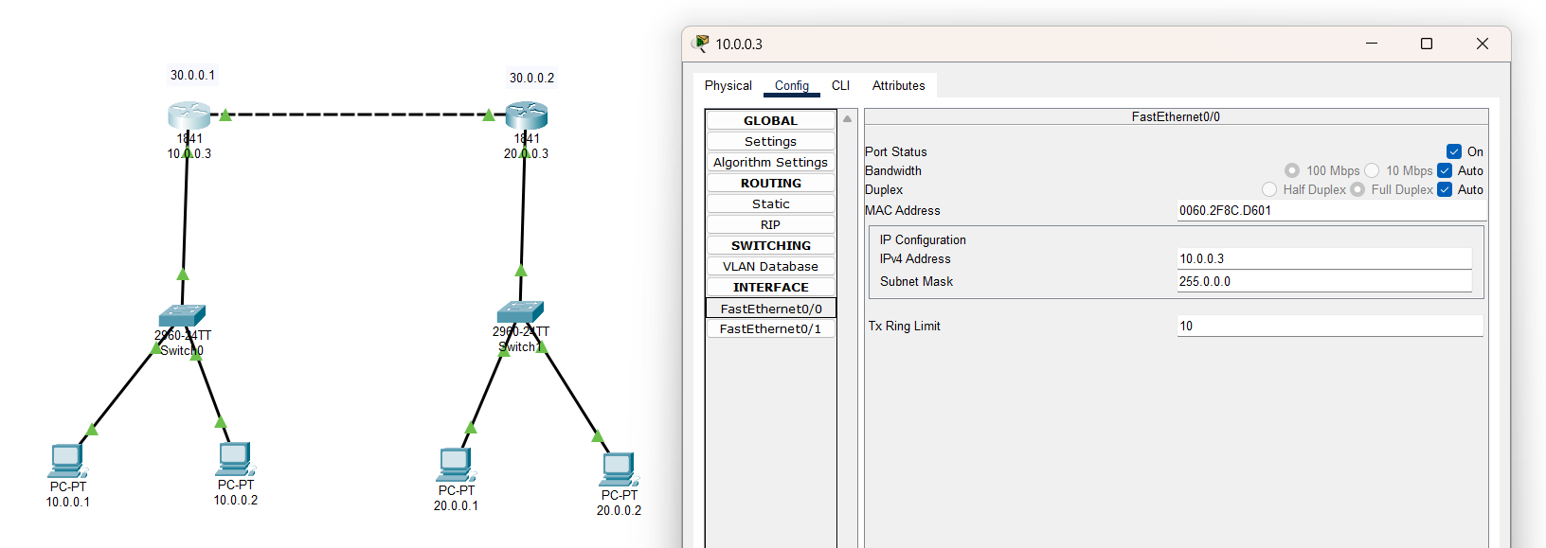
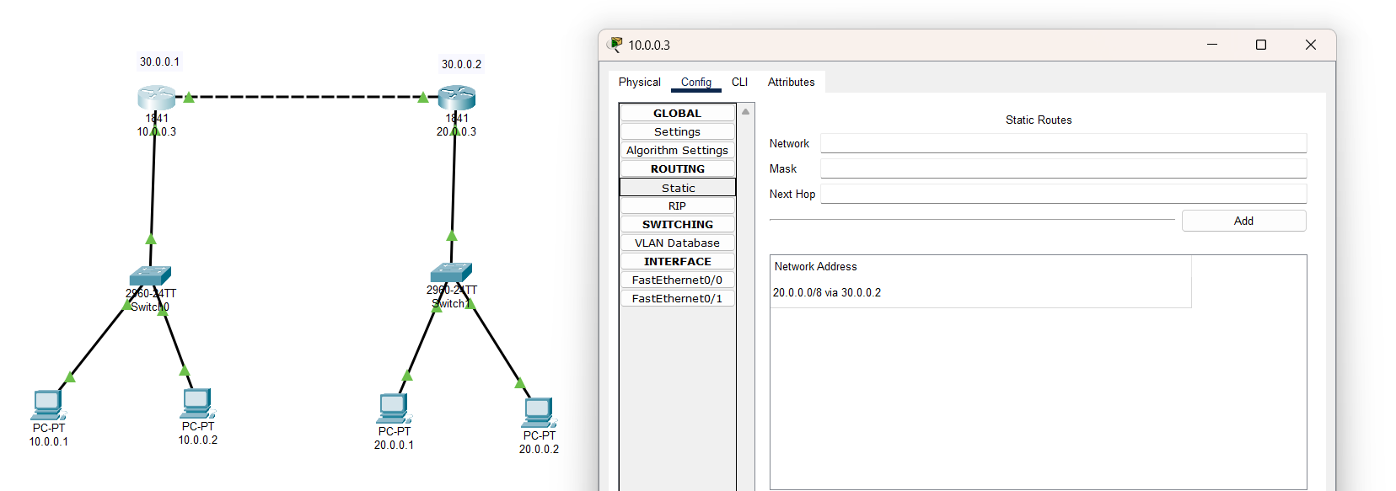
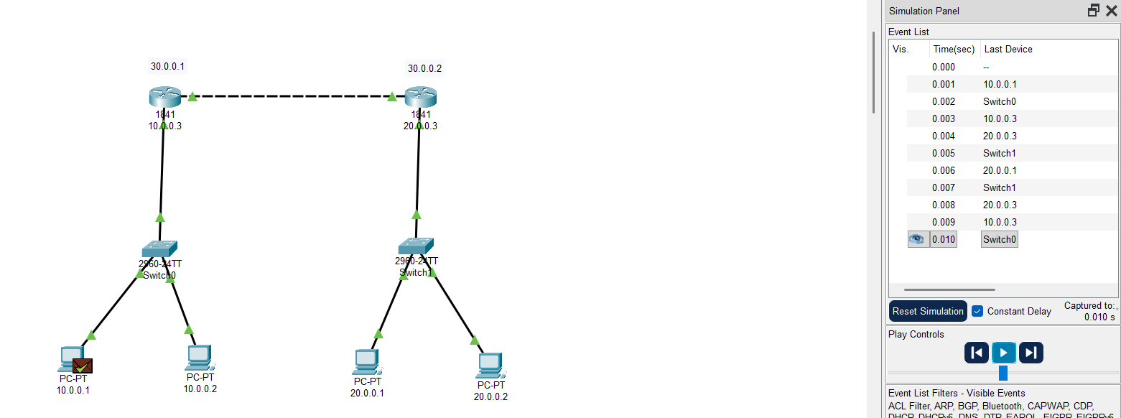

- Connect the three different networks based on the calculated IP addresses and subnet using a packet tracer.
